OSHA, ANSI, and Press Brake Safety

By Bruce Meyer

Customers constantly ask us what are the best ways to prevent having problems with OSHA, keeping operators safe and how can they still make a profit staying on the right side of the law. We know what the standards are, what the documents say and what our customers have told us about their inspection experiences.

As we understand it, the OSHA inspector’s job is to observe the operator demonstrating safe press brake operation. In OSHA’s online Machine Guarding section they list 4 guarding solutions for press brakes. First is the use of a presence sensing device, next is use of a two hand control, then by using pullback or restraint devices. Installation and proper use of these devices would then allow for operators to remain safe when forming sheet metal. Except for presence sensing devices the other methods are not practical because several violate ergonomic considerations while others hamper production throughput significantly.

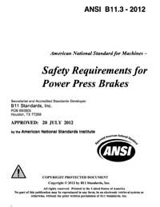Presence sensing devices such as light curtains, mats, area detectors and the newer AOPD (active opto-electronic protection devices) systems that follow the moving component offer a higher standardized technological approach to keeping operators safe. Some are better at the job than others. Some can be defeated and others can not. Some offer protection right up to where the tools close for small parts or flanges and others have to be fitted farther away from the point of most danger. AOPD systems that follow the moving component provide the best all-around alternative. They can be retrofitted to older press brakes, are the least intrusive, are adaptable to almost 95% of normal forming situations and provide the least impact to production throughput.

The ANSI B11.3-2012 is the most accurate document of its kind, providing a genuine framework for keeping sheet metal forming operations safe and corporate profits flowing. When 50 industry experts met in Las Vegas in 2012 to hammer out the important details, OSHA was invited but considered their attendance a conflict of interest. Since then OSHA has not embraced the ANSI B11.3 concepts nor do they recommend any specific type of the newer technologies. A lot of our inquires come from distressed customers already fined but seeking relief from a surprise return visit that is often 10 times as costly. (Recently a well-known furniture manufacturer from Wisconsin was fined over 2 million dollars for 39 violations that were not addressed.) Confused about what to do, customers look for experienced vendors with successful histories of solving these complicated safety issues.

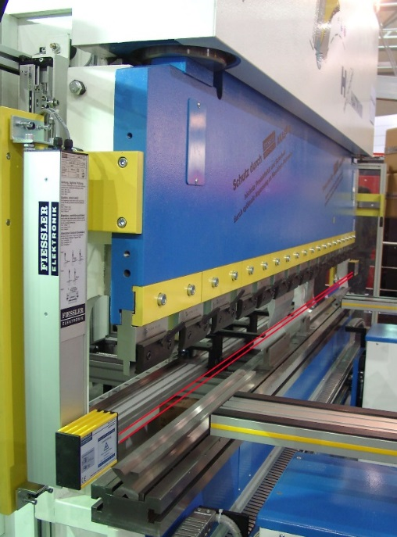Inherent design limitations of infrared light curtains are well documented in the annals of accident history, preventing them from use as point of operation guarding. OSHA refers to a decades old “Hand Speed Constant” theory to define the minimum distance to the point of danger. OSHA’s minimum distance for using light curtains is 4 inches which severely hampers making smaller parts. But the real deterrent is that the amount of safety provided by a light curtain is entirely controlled by the operator. The ultimate solution is to guard from the point of danger outward so that all potential accident zones are watched. Without changing the base operation of the machine, AOPD (active opto-electronic protection devices) systems that follow the moving component were developed specifically for press brakes to allow operators to safely work within a fraction of an inch from tool closure. Additionally these systems are fast enough, accurate enough and interfaced into the press brake control circuits that monitor real time operating characteristics for improved stopping efficiency. Still press brakes that can’t stop reliably or within 14mm or less are not functioning adequately enough to be fitted.

The ANSI B11.3-2012 design criteria for every press brake suitable AOPD device doesn’t allow operators to directly control the system safety. Some press brakes won’t work at all if the laser isn’t functional. Others will only allow 10mm/s slow ram speed for the entire stroke. This ram movement speed was mentioned repeatedly in the B11.3 document as being the maximum ram travel speed for press brakes not equipped with an AOPD system that follows the ram. Some AOPD designs that follow the moving component are adjusted manually to the tooling while others automatically establish those safety zones and maintain parallelism to the point of danger equally from one side of the press brake to the other.

The one disadvantage of retrofit systems of this nature is the importance of how the press brake system functions when it is required to stop the moving component. Inherently in all electro-hydraulic systems there is a difference in when a command to stop is given and the moving beam actually stops. In the ANSI document a maximum ram speed of ≤10mm/s (0.393”/s) was established as not requiring the ram to stop if the AOPD is interrupted prior to pinch point or mute. This must be known but is different for every press brake and is calculated after installation by testing. This information is then helpful in establishing the position above the material where the ram begins its slow down process.

No longer can the unsafe practice be used where this speed change position was typically set right above the part. A position so close that it was physically impossible for the ram to be moving in forming speed when it came in contact with the material. This faster penetration speed caused the part to whip upward and was an unsafe handling practice just from that standpoint alone. The use of these new higher speed change position requirements often conflicts with production requirements. Using safety equipment is never as fast because speed is often the reason for the unsafe condition. Safe operation attracts less government criticism to eliminate fines by creating an industrial environment where fewer accidents occur.



To ensure that the laser beams are parallel to the punch calibration is mandatory before beginning each new job. It requires 5 steps to complete and ensures the same level of protection from one side of the ram to the other.

1. Place the magnet horizontally on the punch nose to block the laser beam.
2. Turn the receiver key switch ON to energize the system.
3. Press the black button to begin the process, laser moves downward.
4. When the beams are below the punch nose firmly push up on the toggle switch.
5. Turn the key switch back to the OFF or center position.

Within less than 30 seconds the MUTE light will flash dimly showing that the system is ready and the press brake is released for normal use.

Obtain your copy of the ANSI Standard B11.3-2012 here: <http://webstore.ansi.org/RecordDetail.aspx?sku=ANSI+B11.3-2012>