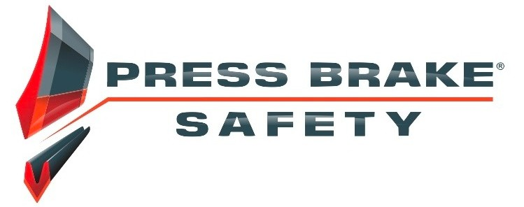

OSHA fines can rise 78%
With passage of the Inflation Adjustment Act effective Aug. 1, 2016, Congress blew the lid off OSHA fines for noncompliance with workplace safety laws. Those fines can–and will–now increase as much as 78%.
Why? While other federal agencies were forced to make sure penalties kept up with inflation, OSHA was exempt. Penalties haven’t gone up for a quarter of a century. Now, OSHA is required to make up for lost time.
What does a 78% increase equate to in dollars?
- Top penalty for most violations: up from $7,000 to $12,471
- Top penalty for willful or repeated violations: up from $70,000 to $124,709
States that operate their own Occupational Safety and Health Plans are required to adopt maximum penalty levels that are at least as effective as federal OSHA penalties.
For detailed information and resources, visitwww.osha.gov/penalties/.
Will OSHA say your company has risked safety in favor of lower costs–and hit you with the new, costlier fines? Start taking steps now to ensure compliance.

Re-check the point of operation.
Original equipment manufacturers (OEMs) don’t assume responsibility for the point-of-operation piece of the safety system. It’s the user’s responsibility. If you don’t have staff with safety competency, you may be inadvertently shirking this critical safety procedure.
Assess press-brake foot controls.
What happens if the foot controls are mistakenly activated while an operator’s hand is in the point of operation? The American National Standards Institute (ANSI) recommends a three-position foot pedal that an operator can step on to get out of a press brake. A foot control coming on when it's not supposed to is among the top causes of operator amputations.
Warn crew against shortcuts.
Hold operators as accountable for safety as for production, such as locking or tagging out during adjustments, jams, cleanings, etc. And make sure everyone knows that a second person must never operate the controls while an operator works on the press.
For press brakes, the best way to ensure worker safety and compliance is to use a laser-guarding safety system.
What questions do you have for us about avoiding increased OSHA fines? Give us a call at (800) 901-1193 Ext 700.

